**Project Background**

This report presents the **Gross Profit Performance** of Plant Co. across 2023 and 2024 with a focus on Gross Profit, Quantity, and Sales for three product types: Indoor, Landscape, and Outdoor. The goal is to provide insights into user behavior, highlight important trends, and make data-driven recommendations that can help to make decision.

Therefore, understanding the market patterns can help improve product wise sales and making effective decision which help especially during critical events like natural disasters.

**. Bottom 10YTD vs PYTD | Country** = This is referring to an analysis of the 10 lowest-performing entities within a country, comparing their performance this year versus the same period last year.

**. Gross Profit YTD vs PYTD =** Is an analysis comparing how much profit has been generated in the current year versus the same period last year, helping businesses track financial growth, profitability trends, and performance fluctuations.

**. Account Profitability Segmentation | GP% and GP =** This analysis helps businesses identify high-margin and low-margin accounts, optimize resource allocation, and make strategic financial decisions.

**Executive Summary**

The Plant Co. Gross Profit Performance report for 2023 shows a slight decline in overall profitability year-over-year. **Gross profit YTD** is **$5.15M**, compared to **$5.42M** PYTD, a drop of **$0.27M** (≈ 5%). The **gross profit margin (GP%)** remains strong at **39.6%**. The primary driver of the shortfall is a significant downturn in the Chinese market (–$0.405M), which represents a large share of total profit. By product line, **Indoor plants** contribute the greatest share of both sales and gross profit (roughly half of total volume), followed by **Landscape** and **Outdoor** products. The **Outdoor** segment is the smallest contributor and shows relative weakness, suggesting it may require additional strategic focus. Seasonally, the **most profitable months** were **April and November** (each ~$0.50M GP), leveraging strong first-quarter and holiday season demand. In contrast, **May and August** underperformed relative to prior year (notably, June saw a steep GP decline of –$0.15M). These patterns suggest opportunities to shift resources toward high-performing product lines and peak months while addressing lagging areas.

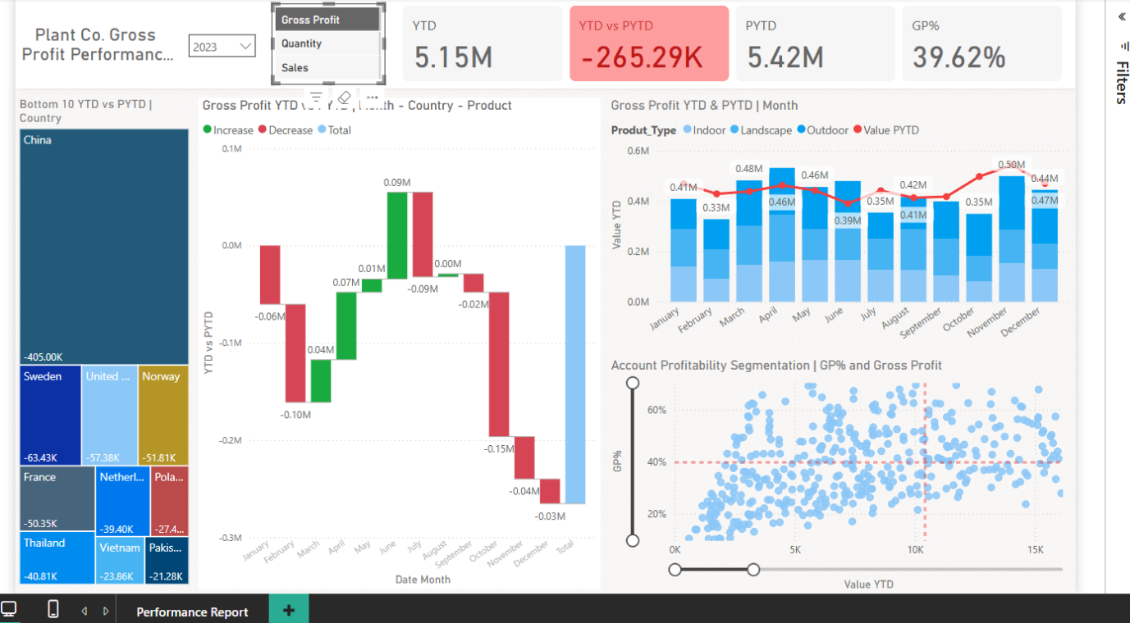

**Summary of Insights**

**Country and Product Demand:** Country-level data reveals that major markets exhibit distinct product preferences. For example, the **United States** leads in total demand across all product types, particularly **Indoor plants**, while **China** also shows strong demand for Indoor but has experienced a marked decline.

**Product-Type Contributions:** Across all products, **Indoor** is the top performer. From the monthly revenue stack chart, Indoor plants (dark blue series) constitute roughly **50% or more** of each month’s sales, with **Landscape** second and **Outdoor** third. In 2023, Indoor products generated the highest gross profit, supporting the overall GP% of ~39.6%. Landscape products contribute moderately, while Outdoor products contribute the least

**Monthly Trends & Seasonality (Condensed Insight)**

* **Peak months:** April and November showed the highest gross profit (~$0.48M and ~$0.50M respectively), indicating strong seasonal demand.
* **Dip months:** June and August underperformed, with GP falling below $0.40M—suggesting potential off-season or sales slowdown.
* **Consistent Performance:** February to May maintained stable GP levels, suggesting these months are reliable for planning campaigns.

**Recommendations**

* **Reinforce Top Product Lines:** Continue to prioritize the Indoor product line, which drives the most sales and profit. Maintain high service levels and marketing support for Indoor plants, especially in peak seasons (spring and pre-holiday).
* **Revitalize the Outdoor Segment:** Develop a strategic plan to boost demand for Outdoor products. This could include targeted promotions, bundling with higher-margin products, or introducing new Outdoor offerings. Evaluate cost structure and pricing to improve Outdoor’s profitability.
* **Address Market-Specific Declines:** Conduct a thorough review of the Chinese market strategy. The –$0.405M GP decline suggests lost demand or pricing pressure. Actions may include localized marketing, adjusting product mix (e.g. promoting top-selling product types in China), or revising pricing and distribution partnerships

**Assumptions and Caveats**

* We need to focus on China, where sales are declining. This may be due to reduced customer interest or pricing issues affecting competitiveness in that market
* We need to focus on the outdoor product category, as its sales have been declining month by month. If no corrective action is taken, this could result in an additional 10–12% drop in sales in the upcoming year.